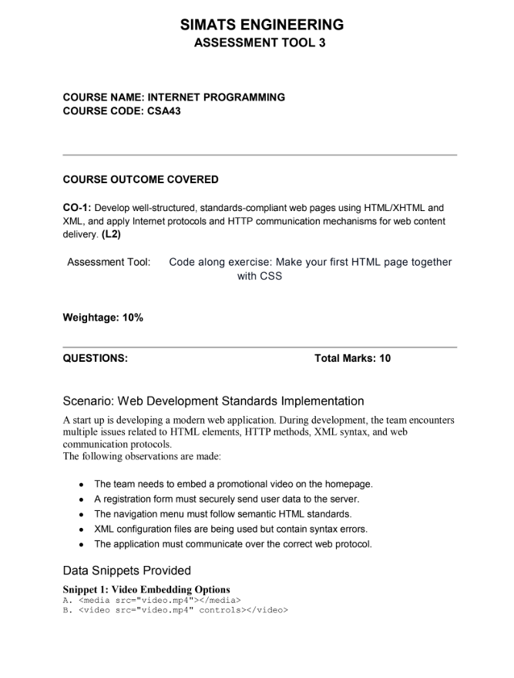

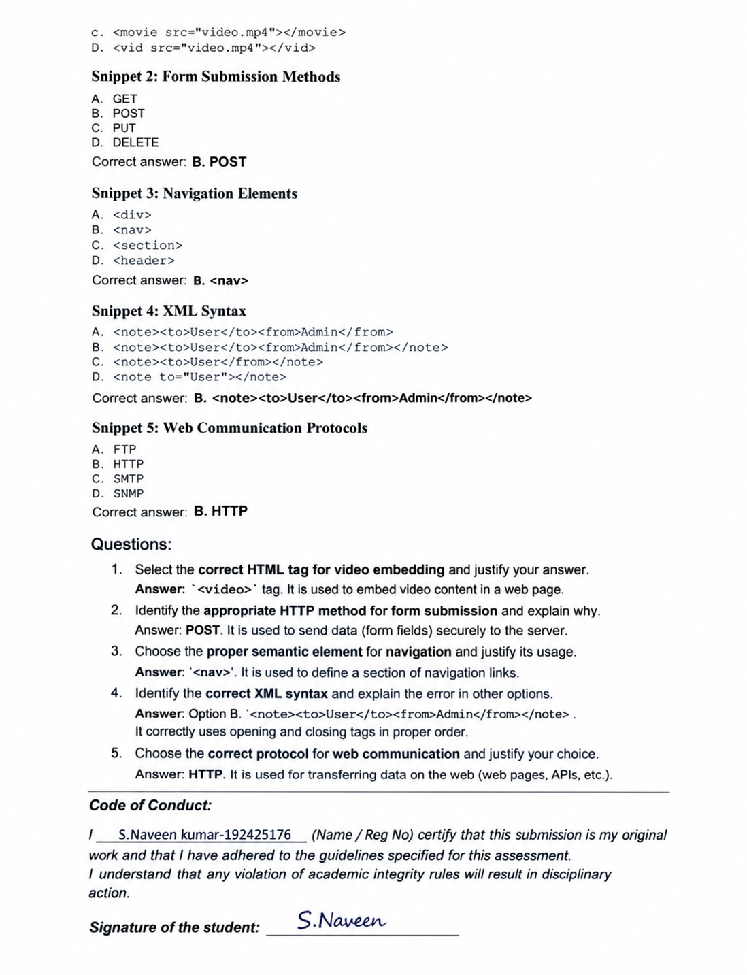

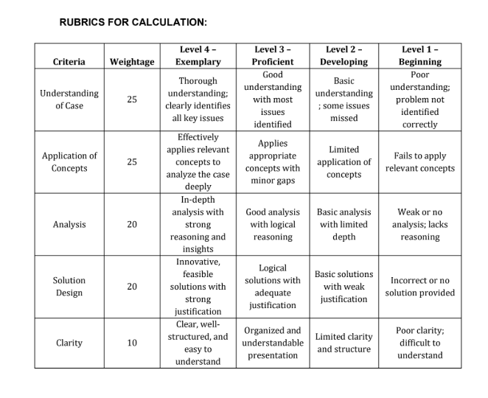

Question 1: Select the correct HTML tag for video embedding and justify your answer.
Answer: Option B – <video src="video.mp4" controls></video>
Justification:
- <video> is the standard HTML5 element for embedding video directly in a page. It plays the file in the browser without any plug-in such as Flash.
- The src attribute gives the file to play, and the controls attribute shows the built-in play, pause, volume, seek and full-screen buttons, so the visitor can control the promotional video.
- Text placed between the opening and closing tags is shown as fallback content in browsers that do not support the element.
- It works with the HTML5 attributes poster, autoplay, muted, loop and preload, and with <track> for captions, which supports accessibility.
Why the other options are wrong:
Option | Tag | Reason
A | <media> | Not a valid HTML element; the browser treats it as an unknown tag and shows no player.
C | <movie> | Not a valid HTML element; it is not defined in any HTML standard.
D | <vid> | Not a valid HTML element; it is only an invented abbreviation.

Recommended implementation:
<video width="640" height="360" controls poster="thumb.jpg" preload="metadata">
<source src="video.mp4" type="video/mp4">
<source src="video.webm" type="video/webm">
Your browser does not support the video tag.
</video>

Providing MP4 and WebM sources improves compatibility, and the poster image and preload="metadata" make the homepage load faster.

Question 2: Identify the appropriate HTTP method for form submission and explain why.
Answer: Option B – POST
Explanation:
- POST sends the form data inside the body of the HTTP request, so it does not appear in the URL, browser history, bookmarks or server access logs. This is essential for a registration form that carries passwords and personal details.
- POST has no practical limit on data size, whereas GET is limited by URL length.
- POST is meant for submitting data that creates or changes something on the server, such as a new user account. It is not cached and is not repeated silently by the browser.
- POST supports file uploads through enctype="multipart/form-data".
POST hides the data from the URL but does not encrypt it, so the form must also be served over HTTPS, and the server should hash passwords and validate input.
Why the other methods are not suitable:
Option | Reason
A. GET | Puts the data in the URL (for example /register?user=ali&pass=1234), so credentials are visible and stored in history and logs. GET is meant only for retrieving data.
C. PUT | Replaces or updates an existing resource at a known URL and is used in REST APIs. HTML forms cannot submit with PUT, and it is not meant for creating a registration.
D. DELETE | Removes a resource. It is the opposite of what a registration form should do, and HTML forms do not support it.

Recommended implementation:
<form action="/register" method="post">
<input type="text" name="username" required>
<input type="email" name="email" required>
<input type="password" name="password" minlength="8" required>
<button type="submit">Register</button>
</form>

Question 3: Choose the proper semantic element for navigation and justify its usage.
Answer: Option B – <nav>
Justification:
- <nav> is the HTML5 semantic element that marks a block of navigation links such as the main menu, a table of contents or pagination. Its name states its purpose, so the code is self-describing.
- Accessibility: screen readers announce it as a "navigation" landmark, so users can jump straight to the menu or skip it.
- SEO: search engines understand which links form the site structure.
- Maintainability: developers and CSS can find and style the menu easily, and the page follows web standards.
Why the other options are not proper:
Option | Reason
A. <div> | A generic container with no meaning. It can hold a menu, but it tells browsers and assistive technology nothing.
C. <section> | Groups related content under a heading (a thematic section), not a set of navigation links.
D. <header> | Holds introductory content such as a logo or title. It may contain a <nav>, but it is not the navigation element itself.

Recommended implementation:
<header>
<nav aria-label="Main menu">
<ul>
<li><a href="index.html">Home</a></li>
<li><a href="about.html">About</a></li>
<li><a href="contact.html">Contact</a></li>
</ul>
</nav>
</header>

Question 4: Identify the correct XML syntax and explain the error in other options.
Answer: Option B – <note><to>User</to><from>Admin</from></note>
Explanation: Option B is well-formed XML. It has a single root element (<note>), every start tag has a matching end tag, and the elements are properly nested, with <to> and <from> opened and closed inside <note>. XML is strict and case-sensitive, and a document that breaks these rules is rejected by the parser.
Errors in the other options:
Option | Code | Error
A | <note><to>User</to><from>Admin</from> | The root element <note> is never closed; the end tag </note> is missing.
C | <note><to>User</from></note> | The start tag <to> is closed by </from>, which does not match, so the nesting is improper. There is also no opening <from> tag.
D | <note to="User"></note | The end tag is incomplete: the closing ">" is missing in </note. (The attribute syntax to="User" itself is valid.)

Rules of well-formed XML applied:
- Exactly one root element.
- Every start tag has a matching, correctly spelled end tag.
- Elements are properly nested (the last element opened is the first closed).
- Tag names are case-sensitive and attribute values are quoted.
A complete configuration file following these rules:
<?xml version="1.0" encoding="UTF-8"?>
<note>
<to>User</to>
<from>Admin</from>
</note>

Question 5: Choose the correct protocol for web communication and justify your choice.
Answer: Option B – HTTP (in practice HTTPS)
Justification:
- HTTP (HyperText Transfer Protocol) is the application-layer protocol designed for the Web. A browser (client) sends a request and the web server returns a response containing HTML, CSS, images, JSON and other content.
- It runs over TCP, by default on port 80, and carries the methods (GET, POST), status codes (200, 404, 500) and headers used to deliver web pages and submit forms.
- For a registration form and user data the application should use HTTPS (HTTP over TLS, port 443). It encrypts the traffic and protects the confidentiality and integrity of the data.
Why the other protocols are not suitable:
Option | Protocol | Purpose (why it does not fit)
A | FTP (File Transfer Protocol, ports 20/21) | Transfers files between hosts; it does not deliver web pages to browsers.
C | SMTP (Simple Mail Transfer Protocol, port 25/587) | Sends e-mail between mail servers; not used for web pages.
D | SNMP (Simple Network Management Protocol, port 161) | Monitors and manages network devices such as routers and switches.

Therefore the startup should deliver the web application over HTTP, secured as HTTPS.

